VEO 3.1 - 谷歌最新 AI 视频生成 - 调用文档

综述
- 谷歌当下最强最新 AI 视频模型
- 生成速度比 Sora 2 快 50%
- 时长只有 8s ，略逊一筹，但提供了首尾帧玩法，可以持续创建连贯性视频。
- 本站仍然是价格屠夫，视频模型对比官网立省 90% 起。
- veo3.1 这里的效果等同于 Google 的 Flow 视频生成平台，此模型为 官逆，而非 官转。
- 支持异步调用

模型卡
- -fl 代表 帧转视频模式（Frame-to-Video），这个才支持图片，且必须传图片。
- -fast 代表快速生成视频模型，用时短、价格更便宜。
模型名 | 描述 | 价格 | 规格
veo-3.1 | 默认竖屏 视频 | $0.25/次 | 720x1280
veo-3.1-fl | 竖屏+首尾帧转视频 | $0.25/次 | 720x1280
veo-3.1-fast | 竖屏+快速 | $0.15/次 | 720x1280
veo-3.1-fast-fl | 竖屏+快速+首尾帧转视频 | $0.15/次 | 720x1280
veo-3.1-landscape | 横屏 标准版 | $0.25/次 | 1280x720
veo-3.1-landscape-fl | 横屏 视频+首尾帧转视频 | $0.25/次 | 1280x720
veo-3.1-landscape-fast | 横屏+快速 | $0.15/次 | 1280x720
veo-3.1-landscape-fast-fl | 横屏+快速+首尾帧转视频 | $0.15/次 | 1280x720

一、同步调用：对话补全接口
使用对话格式生成视频内容。
端点: POST /v1/chat/completions
请求头:
Plain Text
Content-Type: application/json
Authorization: sk-API令牌
请求参数:
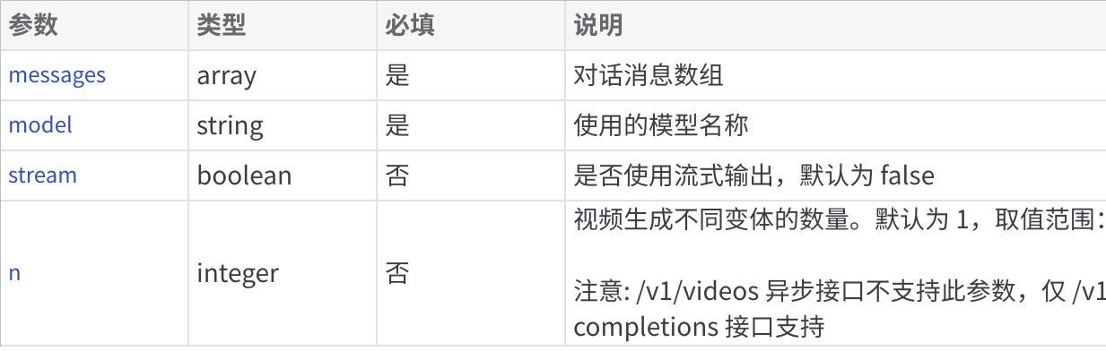
Click the image to view the sheet.

示例 1: 文生视频
Bash
curl --location --request POST 'https://api.apiyi.com/v1/chat/completions' \
--header 'Content-Type: application/json' \
--header 'Authorization: $APIYI_key$' \
--data-raw '{
"messages": [{"role": "user", "content": "画只猪在天上飞"}],
"model": "veo_3_1",
"stream": true,
"n": 2
}'

示例 2: 帧转视频（Frame-to-Video）
如果按异步调用，则见下方章节 2.1 ，上传类型为 multipart/form-data
Bash
curl --location --request POST 'https://api.apiyi.com/v1/chat/completions' \
--header 'Content-Type: application/json' \
--header 'Authorization: $APIYI_key$' \
--data-raw '{
"messages": [{
"role": "user",
"content": [
{
"type": "text",
"text": "根据两张图片生成一个完整的过渡视频"
},
{
"type": "image_url",
"image_url": {
"url": "开始帧图片URL或base64"
}
},
{
"type": "image_url",
"image_url": {
"url": "结束帧图片URL或base64（可选）"
}
}
]
}],
"model": "veo-3.1-landscape-fast-fl",
"stream": true,
"n": 1
}'
说明:
- 开始帧图片：必传，仅限一张。
- 结束帧图片：可选，如果不传则自动生成过渡效果。

二、异步调用方式

1. 创建视频任务
创建异步视频生成任务。
端点: POST /v1/videos
请求头:
Plain Text
Content-Type: application/json
Authorization: sk-APIKEY
请求参数:
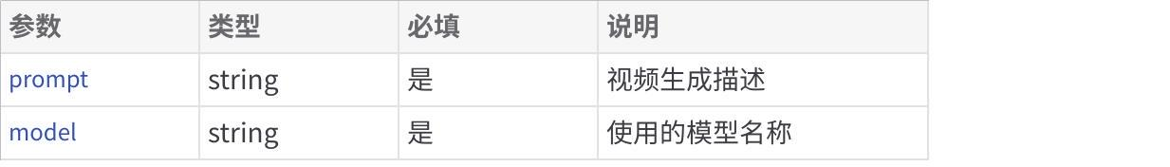
Click the image to view the sheet.

文生视频 异步示例:
Bash
curl --location --request POST 'https://api.apiyi.com/v1/videos' \
--header 'Authorization: $APIYI_key$' \
--form 'prompt="画小猫在跳舞"' \
--form 'model="veo-3.1"'

图生视频 异步示例：
首尾帧玩法，如果需要传两个图，请复用一遍 input_reference
这是 Mac 下，请注意有个@符号引用文件
Bash
curl --location --request POST 'https://api.apiyi.com/v1/videos' \
--header 'Authorization: sk-' \
--header 'Content-Type: multipart/form-data' \
--form 'prompt="让这个画面动起来"' \
--form 'model="veo-3.1-landscape-fl"' \
--form 'input_reference=@"/Users/xxx/Downloads/pic-test.jpeg"' \
--form 'input_reference=@"/Users/xxx/Downloads/pic-test2.jpeg"'

2. 查询视频任务状态
查询视频生成任务的当前状态。
端点: GET /v1/videos/{video_id}
路径参数:
Click the image to view the sheet.
请求头:
Plain Text
Authorization: sk-APIKEY
"model": "veo-3.1-landscape-fl"
示例:
Bash
curl --location --request GET 'https://api.apiyi.com/v1/videos/{video_id}' \
--header 'Authorization: $APIYI_key$'
--header "model": "veo-3.1-landscape-fl"

3. 获取视频内容
获取已生成视频的实际内容。
端点: GET /v1/videos/{video_id}/content
路径参数:
Click the image to view the sheet.
请求头:
Plain Text
Authorization: sk-key
"model": "veo-3.1-landscape-fl"
示例:
Bash
curl --location --request GET 'https://api.apiyi.com/v1/videos/{video_id}/content' \
--header 'Authorization: $APIYI_key$' \
--header "model": "veo-3.1-landscape-fl"

三、常见问题

问：需要传入 size 参数来调整分辨率吗？
答：不需要，通过模型来区分横屏还是竖屏， 默认为竖屏，带 landscape 的横屏。
生成视频的尺寸，格式为 widthxheight
竖屏：720x1280
横屏：1280x720

问：时长可以控制吗？
答：没法，单次调用输出为 8s 。

问：声音如何控制？
答：自带音轨。

问：在 apiyi 后台查看异步任务，发现这个任务是 OpenAI 类型，有问题吗？
答：没有问题，的确 VEO3.1 在我们系统的处理机制和 Sora 2 是一样的，于是这里显示类型为 OpenAI。模型本身能力还是谷歌提供的。
而在异步调用的输出信息里，task_type":"sora2_video_generation"，也只是一个显示类型。
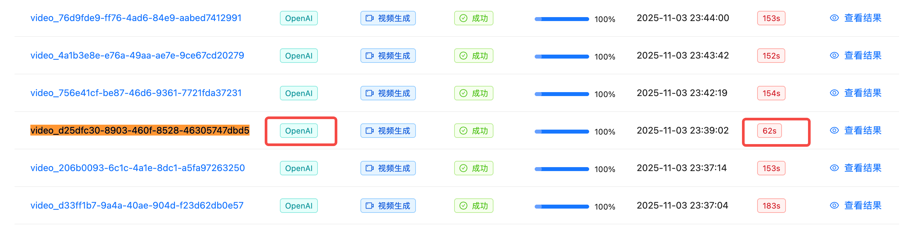

附：流式调用的输出结果示例
SQL
data: {"id":"foaicmpl-2853cd7a-3005-464e-8f24-748053cbdb68","object":"chat.completion.chunk","created":1762181811,"model":"veo-3.1-fast","choices":[{"index":0,"delta":{"role":"assistant"},"finish_reason":null}]}
data: {"id":"foaicmpl-2853cd7a-3005-464e-8f24-748053cbdb68","object":"chat.completion.chunk","created":1762181811,"model":"veo-3.1-fast","choices":[{"index":0,"delta":{"content":"```json\n{\n \"prompt\": \"画只猪在天上飞\",\n \"mode\": \"竖屏模式\"\n}\n```\n\n"},"finish_reason":null}]}
data: {"id":"foaicmpl-2853cd7a-3005-464e-8f24-748053cbdb68","object":"chat.completion.chunk","created":1762181811,"model":"veo-3.1-fast","choices":[{"index":0,"delta":{"content":"\u003e ⌛️ 视频正在生成中，请耐心等待...\n\n"},"finish_reason":null}]}
data: {"id":"foaicmpl-2853cd7a-3005-464e-8f24-748053cbdb68","object":"chat.completion.chunk","created":1762181811,"model":"veo-3.1-fast","choices":[{"index":0,"delta":{"content":"\u003e 🏃 进度：9.0%\n\n"},"finish_reason":null}]}
data: {"id":"foaicmpl-2853cd7a-3005-464e-8f24-748053cbdb68","object":"chat.completion.chunk","created":1762181811,"model":"veo-3.1-fast","choices":[{"index":0,"delta":{"content":"\u003e 🏃 进度：18.0%\n\n"},"finish_reason":null}]}
data: {"id":"foaicmpl-2853cd7a-3005-464e-8f24-748053cbdb68","object":"chat.completion.chunk","created":1762181811,"model":"veo-3.1-fast","choices":[{"index":0,"delta":{"content":"\u003e 🏃 进度：27.0%\n\n"},"finish_reason":null}]}
data: {"id":"foaicmpl-2853cd7a-3005-464e-8f24-748053cbdb68","object":"chat.completion.chunk","created":1762181811,"model":"veo-3.1-fast","choices":[{"index":0,"delta":{"content":"\u003e 🏃 进度：36.0%\n\n"},"finish_reason":null}]}
data: {"id":"foaicmpl-2853cd7a-3005-464e-8f24-748053cbdb68","object":"chat.completion.chunk","created":1762181811,"model":"veo-3.1-fast","choices":[{"index":0,"delta":{"content":"\u003e 🏃 进度：45.9%\n\n"},"finish_reason":null}]}
data: {"id":"foaicmpl-2853cd7a-3005-464e-8f24-748053cbdb68","object":"chat.completion.chunk","created":1762181811,"model":"veo-3.1-fast","choices":[{"index":0,"delta":{"content":"\u003e 🏃 进度：54.9%\n\n"},"finish_reason":null}]}
data: {"id":"foaicmpl-2853cd7a-3005-464e-8f24-748053cbdb68","object":"chat.completion.chunk","created":1762181811,"model":"veo-3.1-fast","choices":[{"index":0,"delta":{"content":"\u003e 🏃 进度：63.9%\n\n"},"finish_reason":null}]}
data: {"id":"foaicmpl-2853cd7a-3005-464e-8f24-748053cbdb68","object":"chat.completion.chunk","created":1762181811,"model":"veo-3.1-fast","choices":[{"index":0,"delta":{"content":"\u003e 🏃 进度：72.9%\n\n"},"finish_reason":null}]}
data: {"id":"foaicmpl-2853cd7a-3005-464e-8f24-748053cbdb68","object":"chat.completion.chunk","created":1762181811,"model":"veo-3.1-fast","choices":[{"index":0,"delta":{"content":"\u003e 🏃 进度：83.7%\n\n"},"finish_reason":null}]}
data: {"id":"foaicmpl-2853cd7a-3005-464e-8f24-748053cbdb68","object":"chat.completion.chunk","created":1762181811,"model":"veo-3.1-fast","choices":[{"index":0,"delta":{"content":"\u003e 🏃 进度：90.2%\n\n"},"finish_reason":null}]}
data: {"id":"foaicmpl-2853cd7a-3005-464e-8f24-748053cbdb68","object":"chat.completion.chunk","created":1762181811,"model":"veo-3.1-fast","choices":[{"index":0,"delta":{"content":"\u003e ✅ 第1个视频生成成功，[点击这里](https://veo-video.gptkey.asia/assets/flow/0af272c6-bcc7-48de-8a32-a827bad4392c.mp4) 查看视频~~~\n\n"},"finish_reason":null}]}
data: {"id":"foaicmpl-2853cd7a-3005-464e-8f24-748053cbdb68","object":"chat.completion.chunk","created":1762181811,"model":"veo-3.1-fast","choices":[{"index":0,"delta":{"content":"\u003e ✅ 第2个视频生成成功，[点击这里](https://veo-video.gptkey.asia/assets/flow/9fc24060-ff7a-439e-a4f3-8387d25f63c9.mp4) 查看视频~~~\n\n"},"finish_reason":null}]}
data: {"id":"foaicmpl-2853cd7a-3005-464e-8f24-748053cbdb68","object":"chat.completion.chunk","created":1762181811,"model":"veo-3.1-fast","choices":[{"index":0,"delta":{},"finish_reason":"stop"}],"usage":{"prompt_tokens":16,"completion_tokens":292,"total_tokens":308}}
data: [DONE]

